Use-Case Realization Report
Update Page

Issue <1.0>
Revision History
Date | Issue | Description | Author
12/10/09 | 1.0 | Initial Version | Rajendran Kumaraguru

Table of Contents
1. Brief Description 4
2. Flow of Events 4
2.1 Standard Flow 4
2.2 Exception Flow 4
3. Interaction Diagrams 4
3.1 Collaboration Diagram for Update Page 4
4. Participating Objects 5
5. Class Diagrams 6
5.1 Class Diagram for Update Page 6
6. Derived Requirements 6

Use-Case Realization Report
Update Page

Brief Description
Portal admin will be able to update the existing created pages for the particular company. This operation will be performed only if the content is already available.

Flow of Events

Standard Flow
- Portal Admin log into the system, and go to Page Admin Page.
- Edit outline will be invoked before proceed to update the page.
- By clicking the “btnAdd_Click” button, the Page maintenance screen will be invoked in order to modify the page and its content for the created outline and site.
- Load fields will be used to load the field values.
- Get page will be used to get the particular page before proceed to update the page.
- Validate Fields will be used to validate the field data before proceed to update the page.
- JMD Page Save will be used to save the updated content of the page.
- JMD Page MOD Save will be used to save the module for the updated page.
- Upon updating the page and module it will be shown to the portal admin for the success status.

Exception Flow
- If the page which is not available for editing then the exception should be thrown.
- If any error detected while validating the filed values the error message should be thrown to portal admin.

Interaction Diagrams

Collaboration Diagram for Update Page
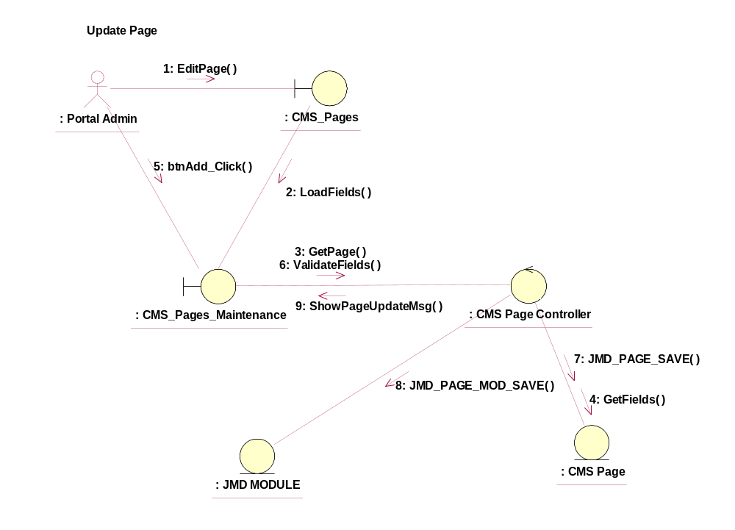

Participating Objects
: CMS_Page
This entity is the page object which will be used in JMD while creating the new pages after creating the outline.
: CMS_Page_Maintenance
This object will be used to create/delete/view/update the pages upon successful creation of the sites and outline.
: CMS_Page_Controller
This is the controller to add,modify,delete and view the page information.
: CMS_Page
This object will be storing the page information.
: JMD Module
This object will be saving the module information after creating the pages.

Class Diagrams

Class Diagram for Update Page
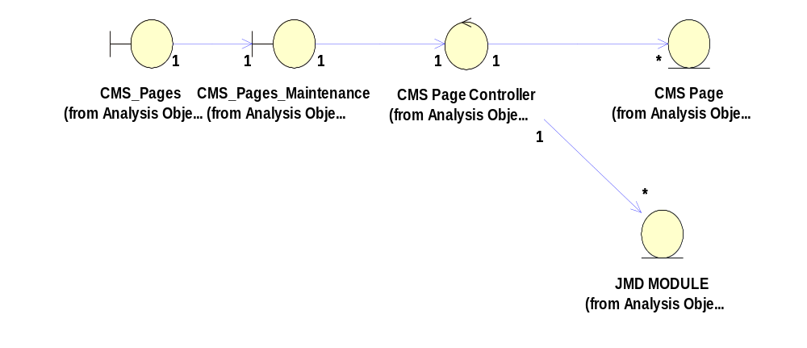

Derived Requirements
[enter the derived requirements here]

